National University of Computer & Emerging Sciences Department of Computer
Science
Operating Systems Lab
Lab # 4

Instructions:
- Make a word document with the convention “SECTION_ROLLNO _LAB-NO”. In addition, paste all of your work done at the LINUX prompt.
- You have to submit a Word File.
- Plagiarism is strictly prohibited; negative marks would be given to students who cheat.

Task 1(Case Statement)
- Create a bash script which will take operator from user and perform multiplication, subtraction or addition according to that operator inside the case statement.

Task 2 (Loops)
- Create a simple script which will print the numbers 10 - 20 (each on a separate line) and whether they are even or odd.
- Write a program that read number as input, calculate, and return the summation of the all digits of the number.
Example:
If given number: 745 Then result will be: (7+4+5) = 16

Task 3 (Functions)
- Write a shell script which takes a positive integer as an argument on the terminal and then checks if it is a palindrome or not. In order to find the reverse of this number it must be passed to function named reverse (), which computes the reverse and passes both, the number and its reverse to another function called palindromeCheck(). palindromeCheck() then compares the numbers and echoes if the number is a palindrome or not.

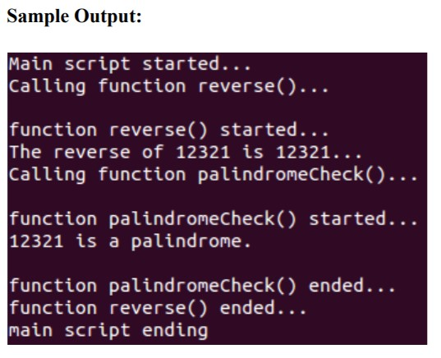
- Write a shell script which calculate the sum of first N natural numbers using recursion.

